16.38: Solving Eq. (16.17) for v, with 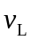= 0, gives
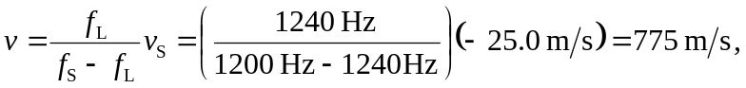
or 780 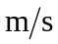 to two figures (the difference in frequency is known to only two figures). Note that 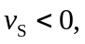 since the source is moving toward the listener.

